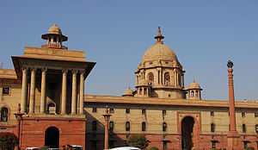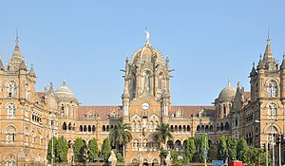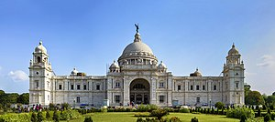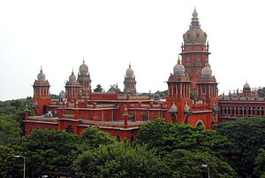

**Indian Art Form - Assignment 4**

**Kunal Keshan**

**RA2011004010051**

**ECE A**

Draw the following kinds of Indian traditional drawings. Take photos at each step and

Paste it along with the final image.

Kolam

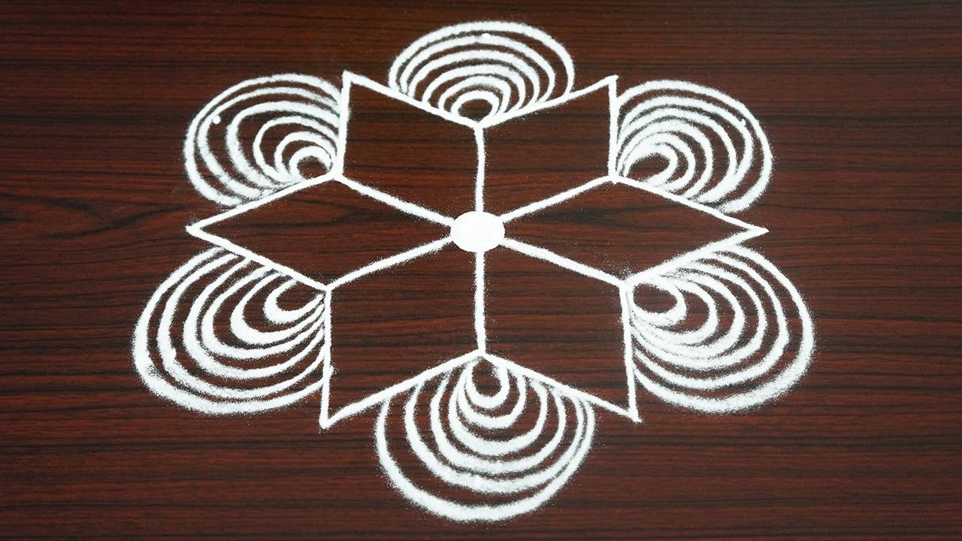

Rangoli

